Capstone Project

My Movie Plan (OUTPUT)

# 

Contents

1. Home page 3

2. Login Page: 3

3. Registration Page: 4

4. User Home page: 4

5. Your Profile: 5

6. Show Details: 5

7. Movie Details. 6

8. Booking Process: 6

9. Stage 2: 7

10. Payment details 7

11. Register New Auditorium. 8

12. Add New Movie: 8

13. Seat Selection: 9

14. Booking Confirmation: 9

15. About us details: 10

16. Contact Us: 10

# Home page

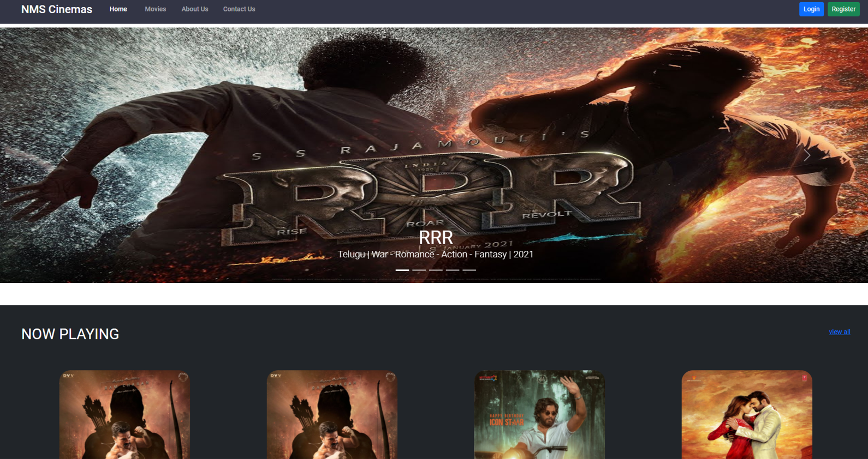

# Login Page:

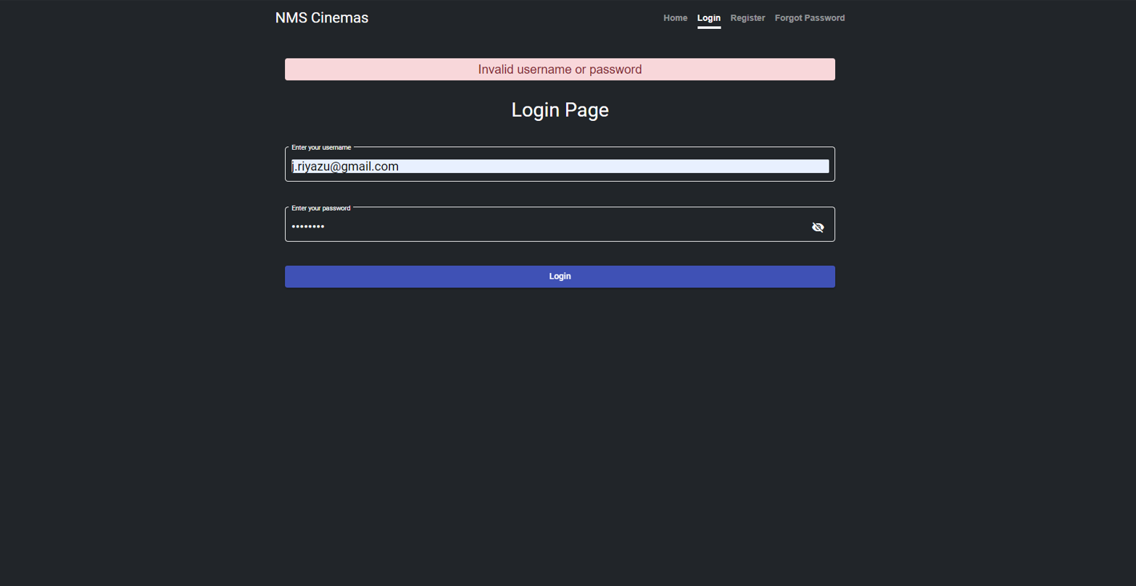

# Registration Page:

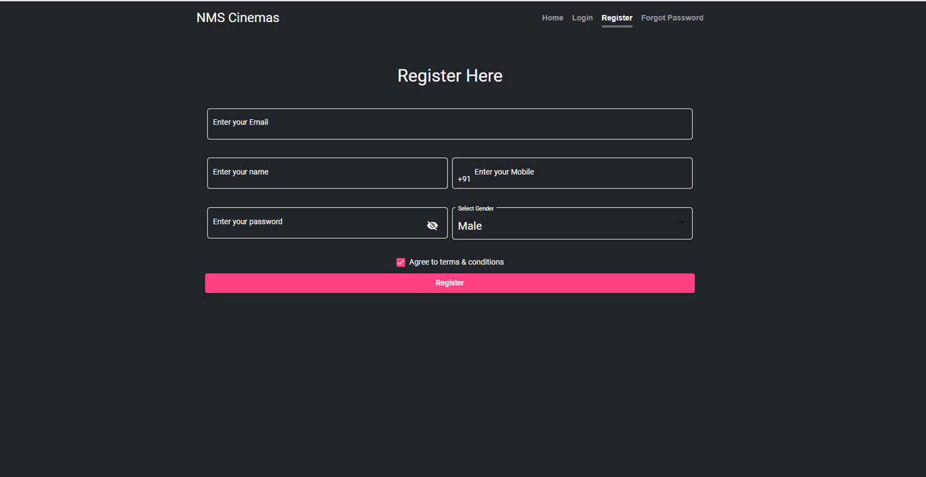

# User Home page:

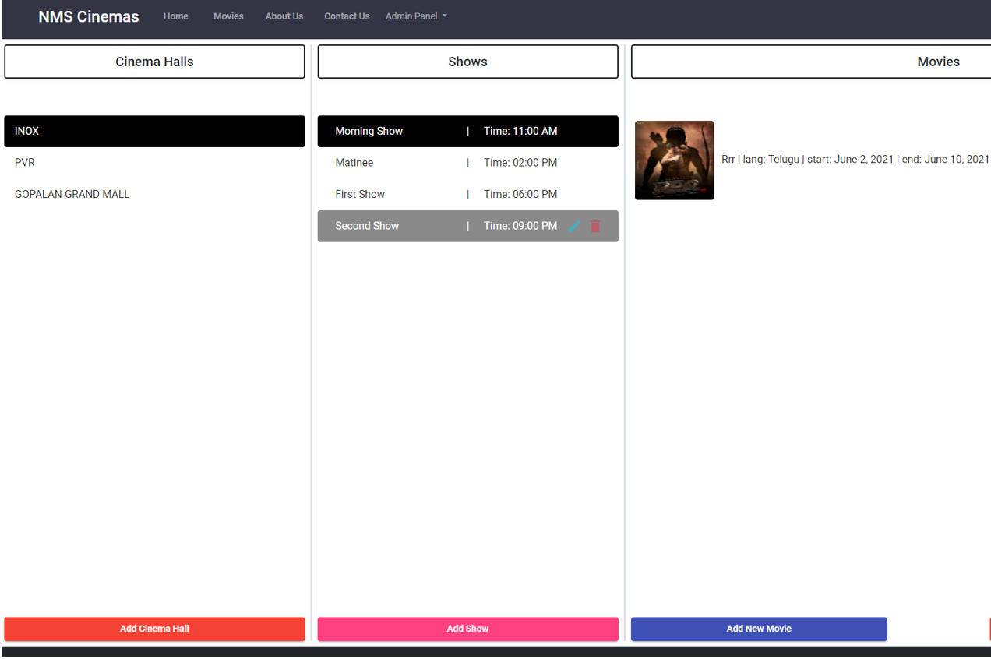

# Your Profile:

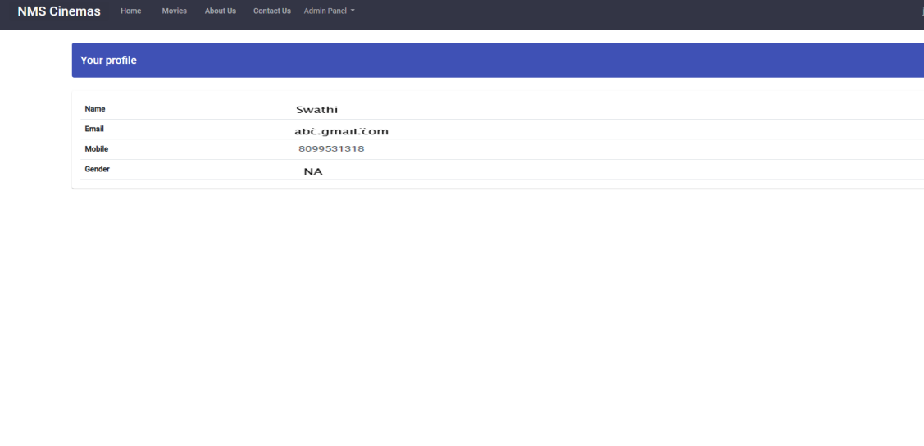

# Show Details:

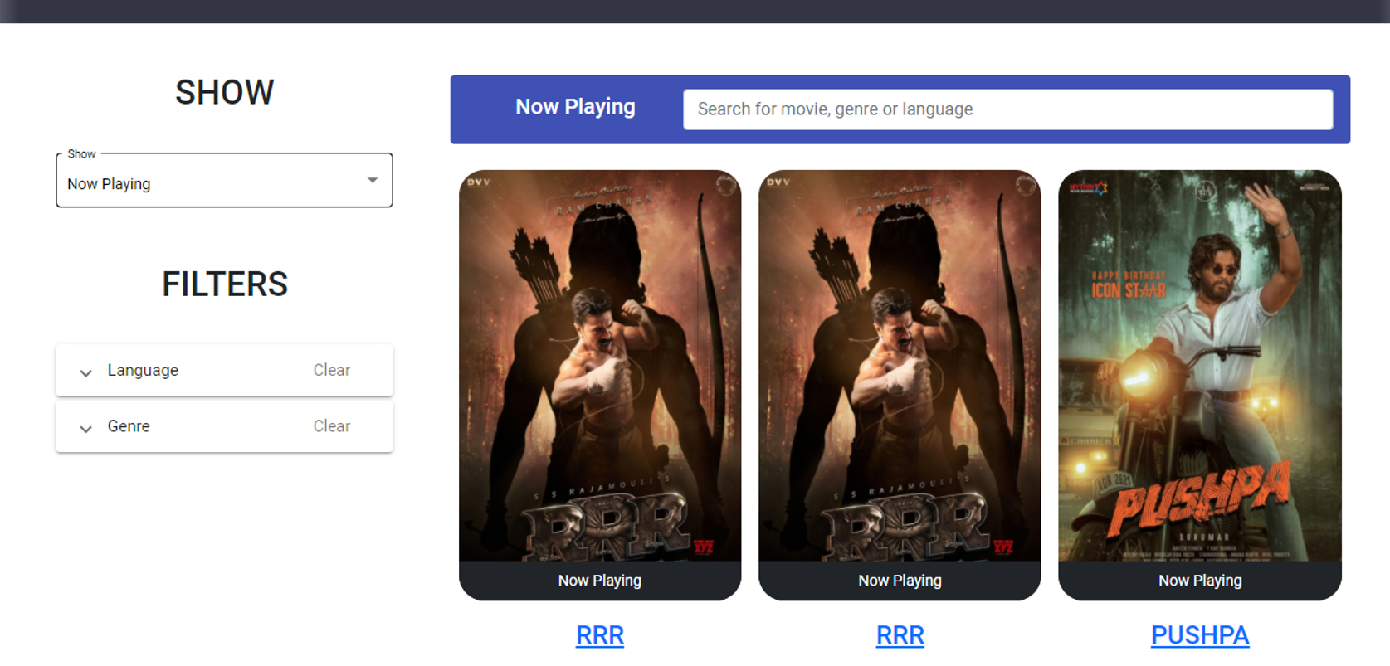

# Movie Details.

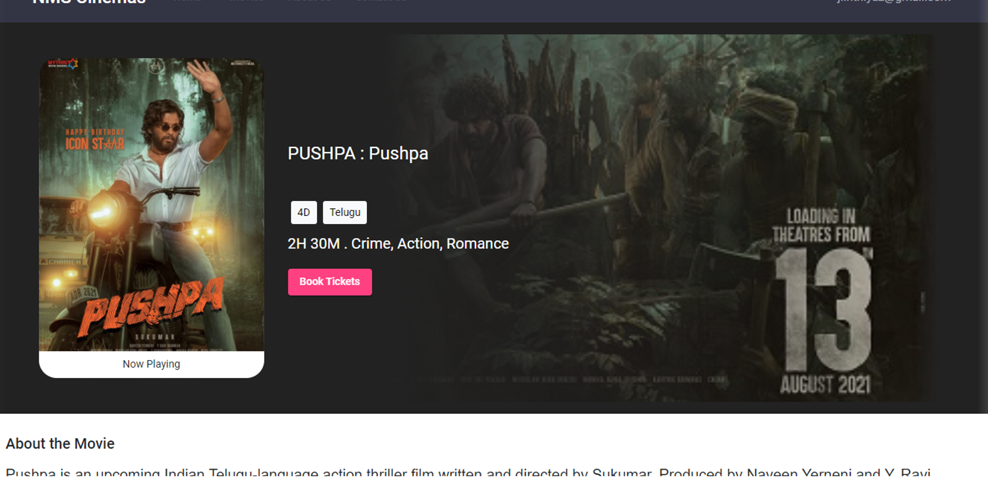

# Booking Process:

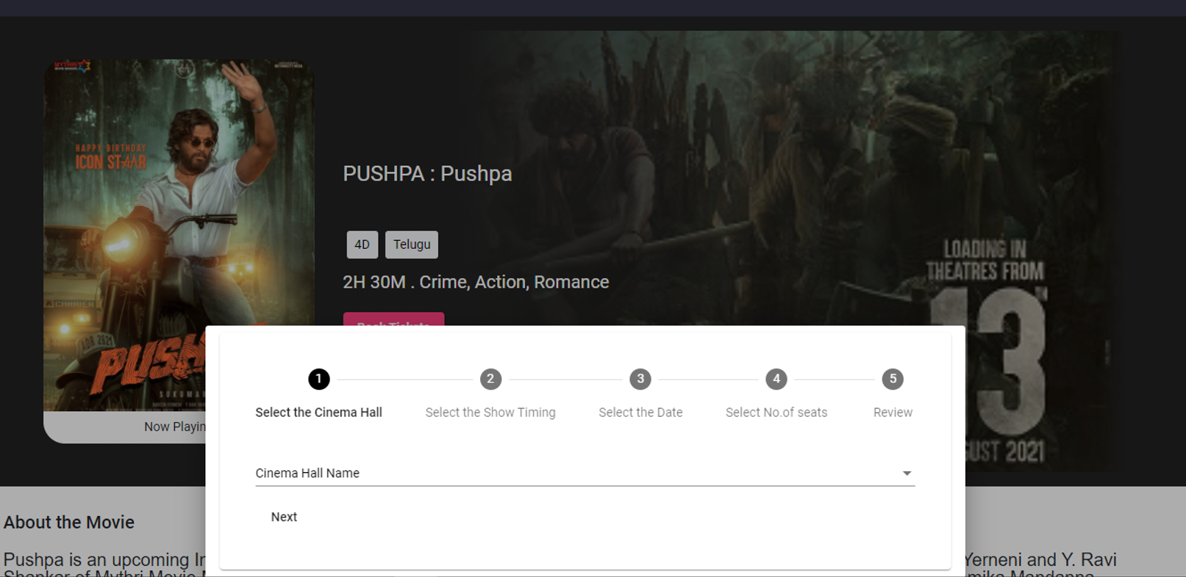

# Stage 2:

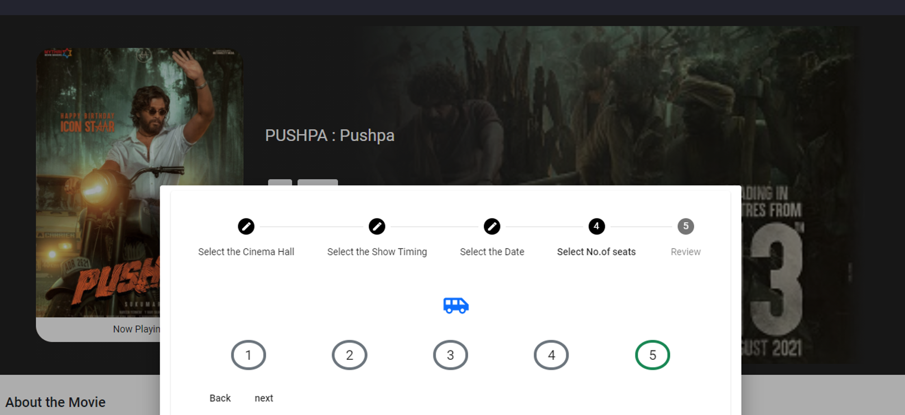

# Payment details

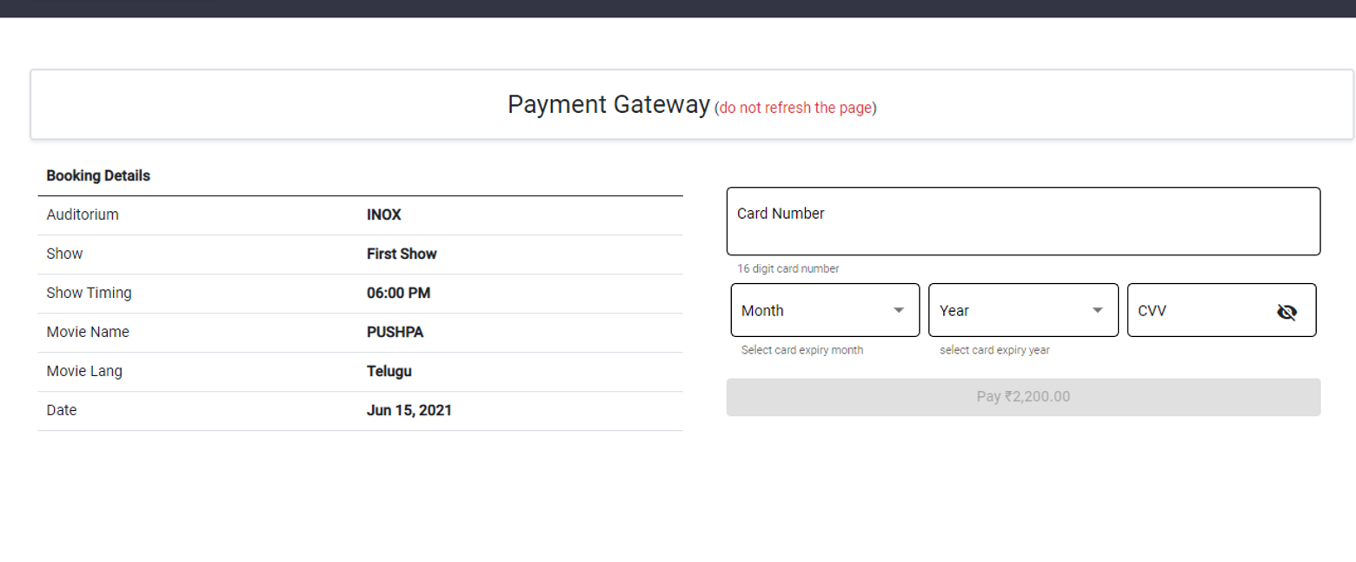

# Register New Auditorium.

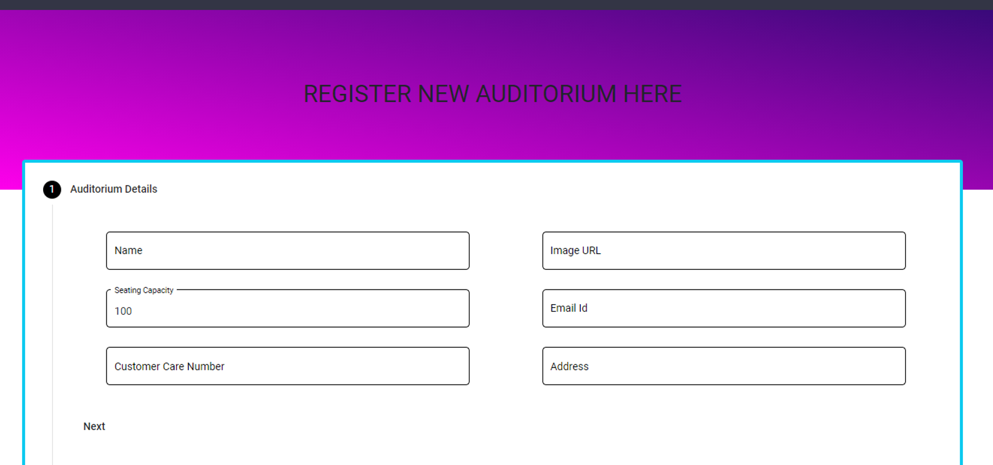

# Add New Movie:

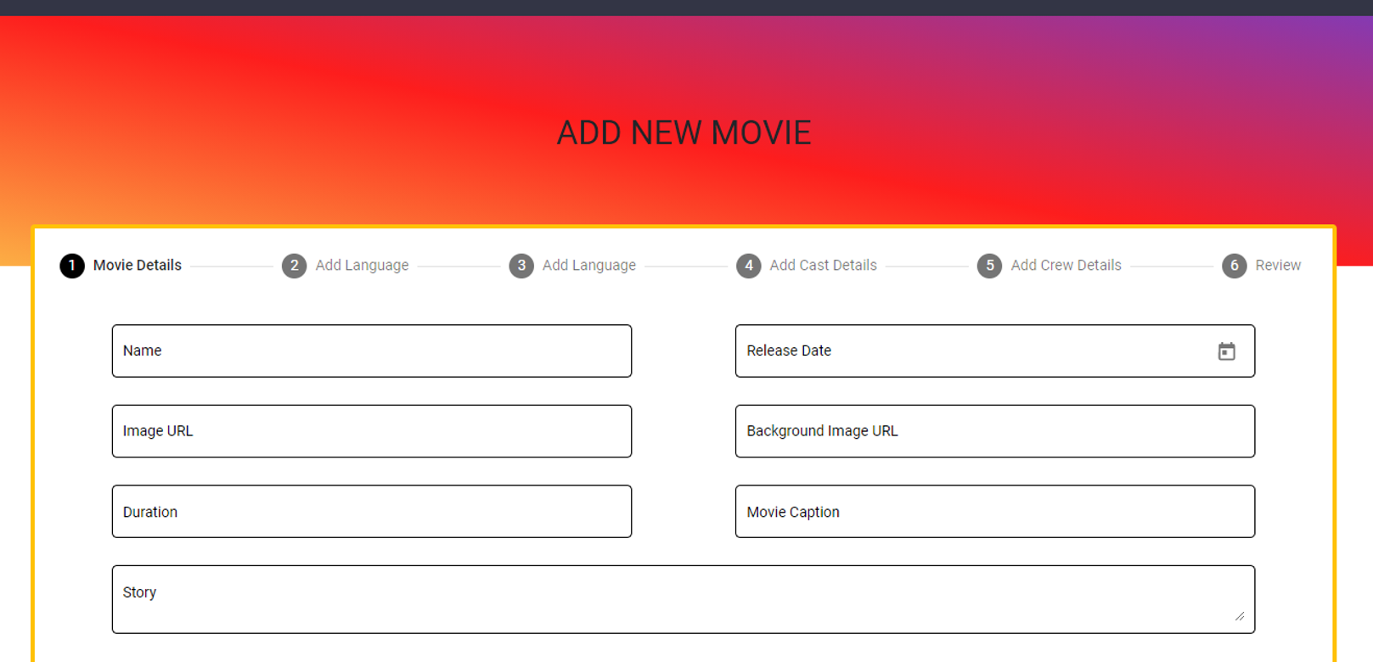

# Seat Selection:

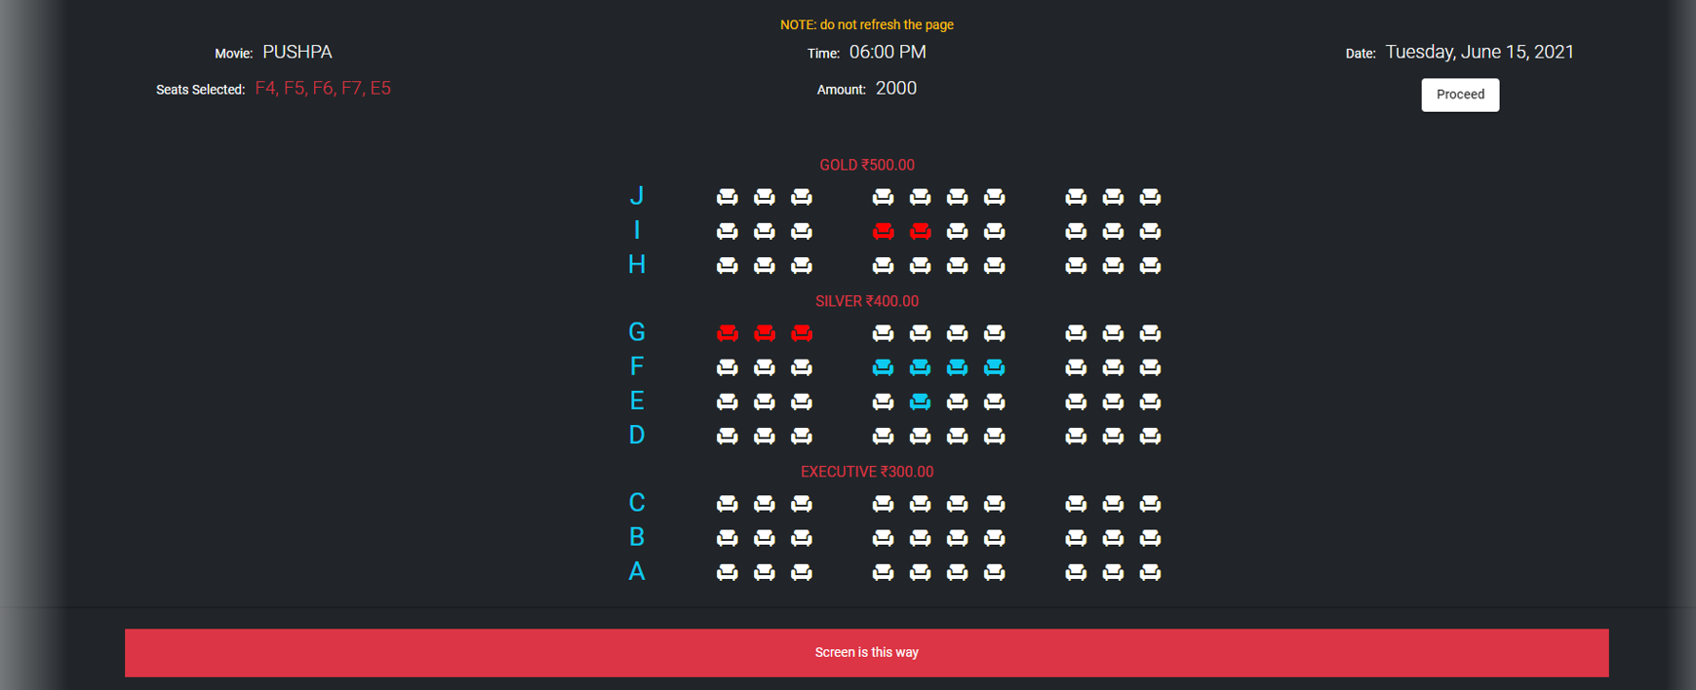

# Booking Confirmation:

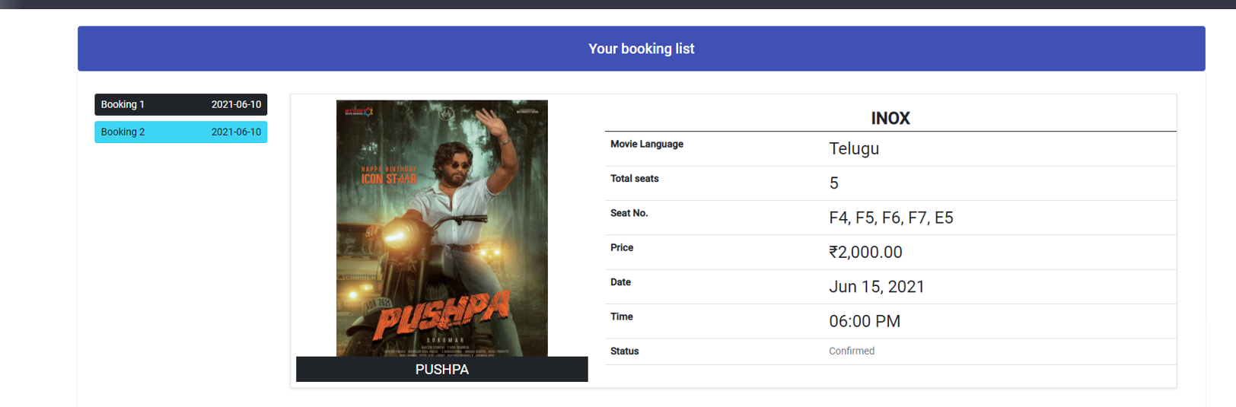

# About us details:

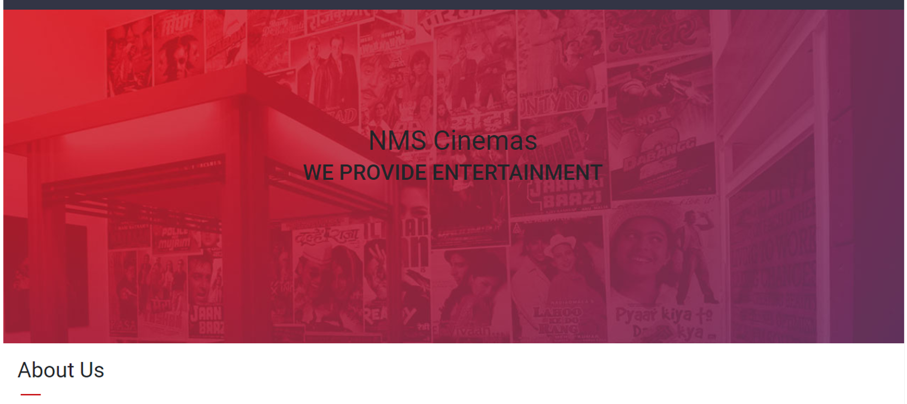

# Contact Us:

